THE HYPERBOLIC DEMAND CURVE

The Utility Function and its Demand Curve

$U=(Q−Q)^{α}⋅(Y−[P−\overline{P}]Q)^{β}$ Utility Function. Y = Income
$P=\overline{P}+\frac{A}{Q/N−\overline{Q}}$. Demand Curve, where:

$$\begin{aligned}Y=\text{Income} \\ N=\text{Number} \text{of} \text{Consumers} \\ A=\frac{αY}{α+β} \\ \overline{Q}=\frac{βQ}{α+β}\end{aligned}$$
$Q∗\overline{Q}+\frac{A}{P−\overline{P}}$
For a given Price, the consumer’s utility-maximizing quantity is
Qbar and Pbar are both considered to be negative.

Characteristics of the Utility and Demand Functions
In search of a usable utility function (i.e. one from which I could derive a demand curve and other properties) I originally considered the Cobb-Douglas function U = Q^{α}⋅(Y – P⋅Q)^{β} which has a nice interpretation. Utility has two sources: Q and all the income left over after buying Q. This function has limited application since it produces a unit elastic demand curve: P = αY/(α+β)Q. Given a unit elastic demand curve, a firm will charge an infinite price. Pbar and Qbar were added to produce a more versatile demand function. Both parameters have plausible interpretations (see below).

THE FIRM:
I will assume a firm with constant Marginal Cost (MC) and demand as shown above for each of its identical customers. The profit-maximizing price (P*) and quantity (Q*) are:
D
Q
P
Pbar
Qbar

The Demand Curve is a hyperbola asymptotic to$\overline{P}$and $\overline{Q}$. These are generally assumed to be negative, meaning that the good has intercepts on both the Quantity and Price axes. The implications are:

1. satiety – There is a limit to the amount of the good one would take at zero price
2. non-necessity. The existence of a Price intercept means that there is a price above which consumers will do without the good. This is strictly necessary for the model, to prevent prices rising to infinity.

With typical parameters the firm appears as shown. (Note the ubiquitous use of constant marginal cost)

Pbar: It is easy to interpret (the negative of) Pbar as the price of a complementary good. I.e. for every unit of Q bought, one must spend Pbar on its complement(s).
Changing Pbar has a large effect on the Q intercept. This “shows” that if the price of complements were to rise, that would impact the quantity I would “buy” at a zero price, since I would still have to buy the more expensive complements even if the good itself had a zero price. This suggests that a fall in the price of complements leads demand to be both higher and less elastic.

Qbar (actually, its negative) relates to the amount of the good “needed.” This suggests that it refers to the availability of substitutes. I.e. having a lot of substitutes makes a particular good less necessary. Here’s a way to think of Qbar. If Qbar is zero the demand curve is asymptotic to Q= 0; the consumer will be ready to pay “anything” to get some – even an infinitely small quantity – of this good. If Qbar is positive then there is some positive quantity that the consumer will pay any price to get. This suggests that Qbar greater or equal to zero denotes a necessity. Likewise, a negative quantity connotes that the good is not a necessity – there is a price above which the consumer will simply do without this good. The more negative Qbar is, then, the further the good is from being a necessity. Typically this means that a large negative value for Qbar describes a good with available substitutes.

Changes of Qbar mostly affect the Price intercept. This says that an increased price of substitutes would raise my reservation price for the “last” unit. It is also interesting that if we interpret a fall of Qbar as a reduction of the price(s) of substitutes we get a demand curve that is more elastic than it was. Since having many substitutes typically increases demand elasticity, this makes sense.

THE CONSUMER
For a given Price, the consumer’s utility-maximizing quantity is
The consumer’s maximum utility is $U∗{\left(\frac{A}{P−\overline{P}}−\frac{α\overline{Q}}{β}\right)}^{α}⋅{\left[Y−A−\overline{Q}(P−\overline{P})\right]}^{β}$ if the good is bought
If none is bought, consumer utility is: $U=(−Q)^{α}⋅(Y)^{β}$

THE FIRM:
I always assume a firm with constant Marginal Cost (MC).
In a market with N identical consumers, the profit-maximizing price (P*) and quantity (Q*) and profit (π*) are:
Note the necessities: Pbar < MC and Qbar <0
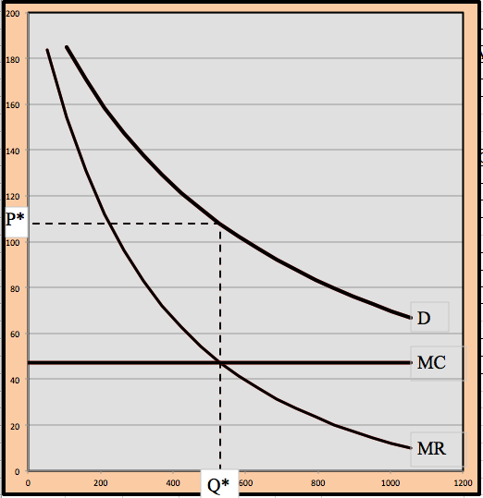
$$\begin{aligned}Q∗N⋅\left[\overline{Q}+\sqrt{\frac{−A\overline{Q}}{\text{MC}−\overline{P}}}\right] \\ P∗\overline{P}+\sqrt{\frac{−A(\text{MC}−\overline{P})}{\overline{Q}}}\end{aligned}$$
$$π∗N{\left[\sqrt{\overline{Q}(\overline{P}−\text{MC})}−\sqrt{A}\right]}^{2}−\text{FC}$$

Hyperbolic Demand and Marginal Revenue
Ways to shift Demand. An intriguing aspect of using this sort of a demand curve is that is now possible
to shift demand in a variety of ways. It matters whether demand shifts “up” or “right.” Similarly demand shifting “down” is different than shifting “left.”
SHIFTS
A. Demand shifts
… up and down | by changing Pbar
B. Demand shifts
… right and left | by changing Qbar

Demand Shifts

An extension of this property is that it is possible for demand shifts to yield (what I call) anomalies. I take the standard result of a demand shift to be that Price and Quantity react by moving in the same direction. An anomalous result is any case in which a Demand shift causes the firm’s equilibrium Price and Quantity to move in opposite directions. The hyperbolic function can produce those results. See the article DemandAnomalies.doc for a fuller treatment.

A Quantity Anomaly occurs when the quantity moves in the opposite direction from demand
A Price Anomaly occurs when the price moves in the opposite direction from demand

SHIFT | Parameter change | D becomes | Possible anomalies
A. Demand Increases
1. right | increase Qbar | less elastic | Quantity
2. up | increase Pbar | more elastic
B. Demand Decreases
1. left | decrease Qbar | more elastic | Price
2. down | decrease Pbar | less elastic

Satiety, a negative $\overline{P}$, is not strictly required. It is strictly necessary that Pbar be less than Marginal Cost; a negative $\overline{P}$ensures that.

