Nonstandard Demand Results
The standard response to the question, “What will a not-perfectly-competitive firm do if its demand rises?” is “Increase Price and increase Quantity.” This is the firm-level analog to the market response to a demand increase. I suspect that:
(a) this is the best single answer to the question
(b) there are significant exceptions.
The purpose of this paper is to examine those exceptions.

In what follows I will deal with firms that have:
a. downward sloping demand (D). This is not about perfectly competitive firms.
b. constant marginal cost (MC). This is a huge simplification with what I see as a small sacrifice of realism. Furthermore, it makes sense that, since my purpose is to examine the role of demand, we should make the cost side as simple as possible. Justifications for this are contained in the file ConstantCostModel.doc.

Let’s illustrate the rule: D↑ ⇒P↑, Q↑ using linear D and constant MC, as shown.
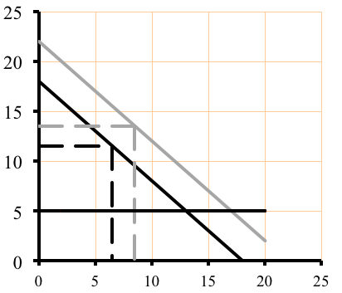
An increase of Demand (D0 to D1) raises both P and Q. I take this to be the standard response. The standard response is: a change in Demand will cause Price and Quantity to move in the same direction.
D₁
D₀
MC

ASIDE1: When the question is, “Why does Price rise when Demand rises?” the answer from an economist usually involves some reference to increasing marginal costs. It is interesting to note that a demand increase can raise price even in the absence of increasing costs (which anyone except an economist knows). Increasing price is typically the profit-maximizing response to a demand increase, even with constant costs. If one sees a price rise in response to an increase of demand, this is not a prima facie guarantee of increasing marginal costs.
END OF ASIDE1.

ASIDE2: P* is halfway between MC and the D intercept. Q* follows from that. The reluctance to use a constant cost model carries a high pedagogical cost. With linear D and constant MC, the profit maximizing Price (P*) and Quantity (Q*) are easy to find without drawing Marginal Revenue. The tidy diagram now makes showing shifts of D easy. With increasing costs the graph of a demand increase to a non-PComp firm is too messy to be useful. The same applies to illustrating rising costs: Easy in the constant-cost case; messy and difficult otherwise. END OF ASIDE2.

ASIDE3: It has often been the case that we divide firms into one of four types. The introduction to the firm with downward sloping demand is often labeled the “monopoly” firm. Given the paucity of decent examples of monopoly, I find that designation a distraction. For most students a common, readily observable type of firm is a small, monopolistically competitive firm. These are the firms I like to begin by describing, though I don’t typically use that vocabulary. It is simply “a firm” or a “Not Perfectly Competitive (NotPC) firm.” There are now two types of firms – PC and NotPC.
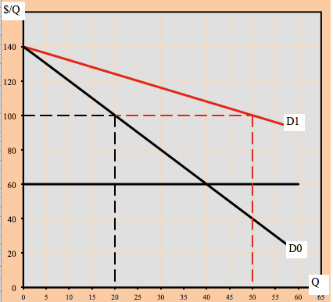
END OF ASIDE3

While this simple linear model nicely illustrates the standard response, it can also generate a borderline exception:

If demand increases by rotating outward from the price intercept, P* does not change. If that particular shift seems contrived, consider that it is precisely the curve shift that would describe a population increase, if the incoming population exactly matched the characteristics of the existing population. So we have a simple case in which the rule: D↑ ⇒P↑, Q↑ is not completely true.

Anomalies. I will label as an “anomaly” any case in which a demand shift leads price and quantity to change in the opposite directions. The rest of this paper is dedicated to the anomalous results.

There are four possible demand anomalies.
 | Price anomaly | Quantity anomaly
D↑ | #1. D↑ ⇒ P↓, Q↑ | #3. D↑ ⇒ P↑, Q↓
D↓ | #2. D↓ ⇒ P↑, Q↓ | #4 D↓ ⇒ P↓, Q↑
Two broad classes of anomalies suggest themselves. The first is some version of increasing returns to scale, where an increase of demand leads to falling costs and hence falling prices. I find this a hugely important case in a world of rapid technological change. I will return to that scenario.

The second broad class of anomalies, to which I now turn, results from changes of the elasticity of demand as demand shifts. This is the case in the demand rotation shown above. To describe this, I will use a vocabulary of marginal demand to describe how, when demand changes, the elasticity of demand is affected. That is, if demand after an increase is less elastic than before, we can say that Marginal Demand is inelastic (that is, inelastic as compared to demand before the increase).

IF | AND | THEN marginal demand is | Possible result from above
D↑ | Ed rises | elastic | #1
D↓ | Ed falls | elastic | #2
D↑ | Ed falls | inelastic | #3
D↓ | Ed rises | inelastic | #4

SAME INFO, Different layout
If marginal demand is | AND | THEN | Possible result from above
elastic | D↑ | Ed rises | #1
elastic | D↓ | Ed falls | #2
inelastic | D↑ | Ed falls | #3
inelastic | D↓ | Ed rises | #4

Stated intuitively we can say that elastic demand suggests lowering price and selling a large quantity, while inelastic demand argues for higher price and smaller quantity. So, for example, if demand rises and becomes more elastic, the firm has opposing impulses. Higher D says raise price, more elastic D says lower price. It could be possible for the latter effect to dominate.

Similarly, if D were to rise (#3) but become less elastic, the firm is again faced with opposing impulses with respect to quantity. It is possible that the impulse to raise quantity (higher demand) is more than offset by the impulse to reduce quantity (less elastic demand).

This can only be of interest if there are a sufficient number of cases such as these.
This paper will (a) list cases that are perhaps describable as non-standard demand results (b) present a demand equation capable of illustrating these anomalies.

There are two types of examples to be offered.
Example, type 1: We could observe a firm whose demand rises and see if the price might fall as a result. We could ask a bar owner, “How do you behave when demand rises?” (i.e. at 5PM on a Friday). The answer is, “We have Happy Hour with reduced prices on beer.”

Example Type 2: The second type of example would be a comparison of two vendors or two consumer populations one of which has demonstrably higher demand, yet lower price, than the other. (See below)
Qbar
Pbar
Q
$/Q
A Useful Demand Function.
$P=\overline{P}+\frac{A}{Q−\overline{Q}}$Consider the demand curve

This curve is a rectangular hyperbola with asymptotes of Pbar and Qbar. . For what follows, I consider both Pbar and Qbar to be negative, giving the accompanying graph. This function is described in the file “Hyperbolic Equations.”

This approach adds interestingly to the vocabulary of Demand shifts. Instead of demand merely increasing or decreasing, it is necessary to specify how demand shifts. Demand can increase by shifting up or by shifting to the right. Likewise demand can decrease by shifting down or to the left. I am suggesting that sometimes it matters.

A. PRICE ANOMALIES. (Price moves opposite demand)
1. occur when elastic demand enters the market and/or inelastic demand exits (”marginal demand is elastic”)
2. are shown by changes of Pbar – vertical demand shifts

#1. D↑ ⇒ P↓, Q↑. I find this to be the most common nonstandard result

a. Turkeys go on sale at Thanksgiving. Say what you will about the artifice life-cycle of turkeys, it remains true that Thanksgiving caused turkey production, not the reverse.

b. Happy Hour. Beer gets cheap just when its demand is highest

c. Many predictable increases in demand (i.e. radiator repair as summer approaches) result in sale prices. Predictable sales (e.g. white sales) bring out the most elastic demand: much is sold at a lower price. D (a normal day) and d (day of the sale) may cross.

d. This example is different in that it involves a supply side response. It is really an alternative description of increasing returns to scale. A successful good goes into large-scale production; its marginal cost and therefore its price fall. The most striking historical case might be Henry Ford’s automation, but in small ways I think this happens a lot. This result is common enough to deserve examination, because many students think it as the general case. It is actually a combination of rising demand and decreasing costs due to the economies of large-scale production. We conveniently ignore this by saying it falls under the purview of the long run, “and we’re doing short run here.” While this may be true to those schooled in such distinctions, let me suggest why not confronting this possibility is a mistake.
i. It is routinely reported as the case: “If the good catches on, it will go into mass production and its cost and price will fall.” This is not an uncommon thing to hear from informed sources.

ii. We look out of touch if we are forced to ignore something they know to be true. We can tell students that we will not be tackling this particular problem, but it does us no service to pretend we don’t know what they are talking about. This is the sort of thing we are supposed to know about.

iii. The long run is often a very short calendar time these days. Technological progress and scaling-up can happen pretty quickly. To say that it is a long run problem because it requires a change of capital – our definition of the long run – makes us and our discipline look even stupider.

iv. Furthermore, the distinction between the long run that involves only a change of the quantity of capital and a longer run that entails a change of technology seems an outmoded concept.

#2. D↓ ⇒ P↑, Q↓.
a. It’s hard to find a buggy whip these days and they are awfully expensive (This is the negative of #1d, above). In general, goods with low demand – specialty items -- are high priced precisely because the demand for them is low and they are made with low-tech techniques.

b. cigarettes. The people who quit smoking composed the most elastic portion of cigarette demand. When they left, the remaining demand elasticity had decreased.

B. QUANTITY ANOMALIES (Quantity moves opposite demand)
1. occur when marginal demand is (relatively) inelastic
2. are shown by changes of Qbar, vertical shifts of demand

#3. D↑ ⇒ P↑, Q↓
a. Target vs. Wal-Mart. As counter-intuitive as it may seem Wal-Mart has lower demand than Target. This is clear from asking the question, “If prices were the same in both stores, at which one would you shop?” Target is the winner. Target has higher Demand, higher prices and lower quantities sold.

#4 D↓ ⇒ P↓, Q↑
a. Wal-Mart vs. Target.

b. After-Xmas sales of ornaments. What happens when the inelastic portion of demand leaves the market.

Substitutes and Complements.

THE MEANINGS of Pbar and Qbar

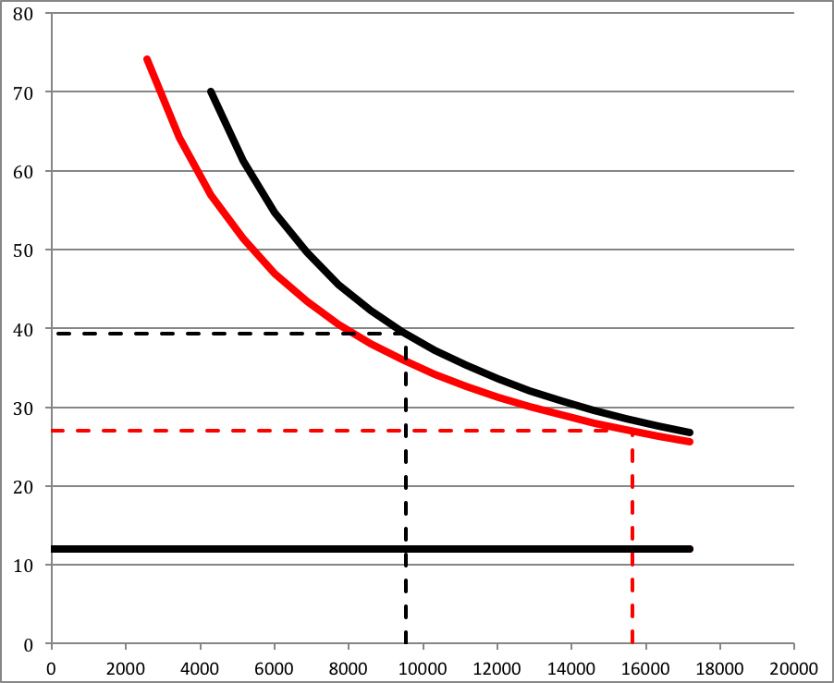
Pbar: It is easy to interpret (the negative of) Pbar as the price of a complementary good. I.e. for every unit of Q bought, one must spend Pbar on its complement(s).

Changing Pbar has a larger effect on the Q intercept. This “shows” that if the price of complements were to rise, that would impact the quantity I would “buy” at zero price, since I would have to buy the more expensive complements even if the good itself had zero price.

Qbar (actually, its negative) relates to the amount of the good “needed.” Qbar can be thought of as being determined by the extent to which a good is perceived to have attractive substitutes. Rising Qbar indicates that this good is seen to have fewer attractive substitutes.

Changes of Qbar mostly affect the Price intercept. This says that an increased price of substitutes would raise my reservation price for the “last” unit.

Raising Qbar would be of great value to a firm: it makes demand higher and less elastic. I believe that advertising and improvements of product quality are both attempts to raise Qbar, to make the good seem less of a substitute for other goods.

PREDICTIONS

A. Demand Increase
1. Price of Substitutes rises. (Qbar rises – less negative) yields large ΔP, small ΔQ

2. Price of Complements falls (Pbar rises – less negative ) yields large ΔQ, small ΔP

B. Demand Decrease
1. Price of Substitutes falls. (Qbar falls – more negative) yields large ΔP, small ΔQ

2. Price of Complements rises (Pbar falls – more negative ) yields large ΔQ, small ΔP

In every case the “small” changes are potentially anomalous.

Characteristics of the Demand Function

The demand function P = Pbar + A/(Q –Qbar) can be derived from a utility function
U(Q) = (Q - Qbar)^{α}⋅(Y – (P – Pbar)Q)^{β}
[Y = Income]
I originally used the function U = Q^{α}⋅(Y – P⋅Q)^{β} which has a nice interpretation. Utility has two sources: Q, and everything else that could be purchased (Y - P⋅Q). I.e. all the income left over after buying Q. This function has limited application since it produces a unit elastic demand curve:
P = αY/(α+β)Q

Given a unit elastic demand curve, a firm will charge an infinite price. Pbar and Qbar were added to produce a more versatile demand function.

The Excel program “HyperbolicDemand” uses this function. One can change Pbar and Qbar (and other variables) and observe the resulting anomalies.

$\begin{aligned}P=\overline{P}+\frac{A}{Q−\overline{Q}} \\ P∗\overline{P}+\sqrt{\frac{A(\overline{P}−\text{MC})}{\overline{Q}}} \\ Q∗N∗\left[\overline{Q}+\sqrt{\frac{A\overline{Q}}{\overline{P}−\text{MC}}}\right]\end{aligned}$

As a test of its perceived realism, ask a company accountant whether they can answer the question, “What is the variable cost per unit of your product?” If the answer is a single number, then the accountant agrees with my simplification. We can stipulate that cost is constant only over a relevant region.
Q* is halfway between the y-axis and the intersection of MC and D.
What qualifies as “sufficient” is open to question. We think inferior goods are an exception worth mentioning. We usually do not mention the exceptions to a statement such, “Long run demand is more elastic than short run demand.”
This demand curve has the attraction of being derivable from a Utility Function U = (Q-Qhat)^{α}⋅(Y – (P – Pbar)⋅Q)^{β}
See the utility curve from which hyperbolic demand is derived

