USES OF THE CONSTANT COST MODEL.
An earlier version of this paper was presented at the 14th annual Teaching Economics Conference at Robert Morris University and published in the conference proceedings.

A companion Excel program is LinearDemand.xls. Graphs from the program are used below.

INTRODUCTION AND JUSTIFICATIONS
This paper explores applications of what I call the Constant Cost Model (CCM): A model of a price-setting firm (i.e. one with downward sloping demand) for whom marginal cost can be assumed constant. The assumption of constant marginal cost simplifies a wide variety of problems to the point where they become tractable enough for inclusion in classroom presentation. Furthermore, constant marginal costs allow for many profit-maximizing problems to be solved via spreadsheet. This simplicity suggests that economics teachers ought to consider adding this model to the pedagogical toolkit.

Often the model of a firm with downward sloping demand is labeled “the monopoly model.” I think this terminology is unhelpful given that the most readily observable firms in our economy are monopolistically competitive. The effect of competition on the slope of demand is worth discussing, particularly with the concept of elasticity in hand, but a firm can be very small and still acutely aware of the effect of price on quantity sold. Many of the applications to be discussed involve small firms.

Since it is central to much of economics to picture the world as dominated by the concept of increasing costs, and since a significant task of the principles course is to establish the increasing cost paradigm in the minds of students, use of constant cost models is necessarily suspect. I offer the following justifications.

The constant cost model …
- allows one to explore many applications in a suitably simplified model. Most of this paper explores this point.
- allows one to easily present otherwise virtually intractable graphical problems (e.g. shifts of a firm’s downward-sloping demand curve; changes of cost when demand slopes)
- corresponds to the firms most readily observable to students: downward sloping demand with a small enough range of output to make increasing costs irrelevant.
- is particularly amenable to describing retail firms, where MC corresponds to the wholesale price of the product.
- is the easiest introduction to the concepts of cost, revenue and profit, with much simplified numerical examples.
- is the simplest model for exploring a firm’s pricing behavior.
- reduces the types of costs to two: those which depend on output and those which don’t. I.e. for this purpose, MC and AVC are the same thing.
- is a springboard to presenting the topic of increasing costs. One can specifically point to errors in business decisions if owners erroneously perceive marginal costs to be constant.
- is symmetrical with the perfect competition model. A powerful reason for studying perfect competition is that it permits concentration on the role of increasing costs by using the simplest possible revenue assumptions. CCM allows one to look at demand and revenue considerations using the simplest possible cost assumption.
- is congruent with reality. I ask students to interview a seller to find out how they arrive at a product price. I don’t recall an answer that involved the concept of increasing costs. While this provides an excellent reason for teaching about increasing costs, it is also nice to have in hand the model that corresponds to what they are being told.
- in conjunction with the perfect competition model, shows that one arrives at the maximizing quantity -- arrives at the point of “enough” -- through two possibilities: either costs rise or benefits fall.
- is a frequently used problem in algebra and accounting, usually to demonstrate the break-even problem.

ALGEBRA
Following are the algebraic notation and results to be used.

v = marginal cost = variable cost per unit, assumed constant
F = Fixed Cost
ATC = v + F/Q
Qc = firm’s maximum output; its “capacity”

Demand: P = A - BQ (linear)
Ed (demand elasticity) = A/(BQ) - 1

With this we have already established the two seminal facts of the life of a firm: demand and cost. We assume that firms maximize profit, where
π = (P - v)Q - F = (A - v)Q - BQ² - F

Maximization conditions: (* denotes profit-maximizing. Q* < Qc)

Q* = (A - v)/(2B) P* = (A + v)/2
π* = (P*- v)Q* - F = (A - v)²/(4B) - F
Ed* = (A + v) / (A - v)

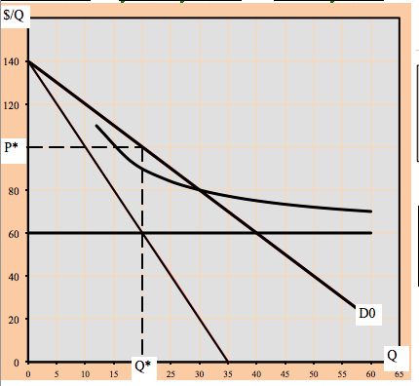GRAPHS
Fig. 1
Much of the attraction of the constant cost model arises from the simplicity of the graphs that follow. Fig.1 shows the CCM graph.
ATC is a rectangular hyperbola, asymptotic to marginal cost. Its height incorporates fixed costs.
$/Q
Q
Fig.2 Profit Maximization
D
equal
Q*
P*
A
v
equal
A
The beauty of the constant-cost model, when combined with a linear demand curve, is the ease with which one can locate the profit-maximizing quantity (Q*) and price (P*).
P* is half-way between marginal cost and the intercept of the demand curve. (i.e. P* = (A + v)/2). Q* can then be found using the demand curve.
(Q* is located half way to the point where demand crosses the marginal cost (v) line. I.e. Q* = (A - v)/2B). See Fig.2.

The big pay-off. This simplicity makes it possible to locate the profit-maximizing output without drawing the marginal revenue curve. This results in a clean, uncluttered graph, especially in the frequent cases where ATC is not needed.

The ease and wealth of recognizable applications when using the CCM has meant that I have often taught micro with this as the introductory topic. From there I introduce diminishing returns and increasing costs and move up to the supply and demand description of market behavior.

I believe another payoff here is that, having seen the simple constant cost/linear demand model, it is easier to intuit P* and Q* with increasing costs and nonlinear demand.

APPLICATIONS
The main point of the following is merely that the assumption of constant marginal cost greatly simplifies the presentation of a variety of problems in which the focus of attention is on the behavior of demand, rather than cost.

There is no supply curve when Demand slopes.
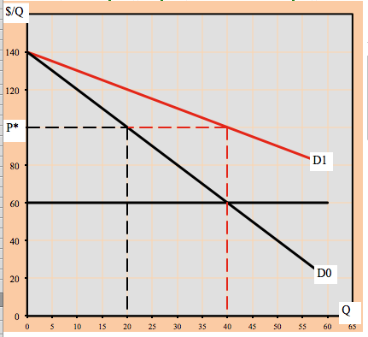The constant cost model provides an easy avenue to establishing that there is not a one-to-one correspondence between price and quantity supplied. Figure 3 shows a case of two different quantities being supplied at the same price. This can be verified by the fact that P* = (A+v)/2, and that neither A nor v has changed.
Fig. 3. Same Price, different Quantity

This case even has a neat interpretation: It illustrates the case of population increase where the new population has the same characteristics as the old. In that case, the reservation price of the most determined consumer (that is, the parameter A) would not change, yet the quantity demanded would be greater at any price than it previously was. A little ingenuity allows one to draw the case in which two different demand curves result in different prices but the same quantity.

The equation for P* establishes that P* cannot be found without knowing something about demand – in this simple case, the parameter A. The answer to question, “At what price would you offer this quantity?” is, “It depends on the shape (particularly, the elasticity) of the demand curve.”

The laws of Supply and Demand generally hold even outside of perfectly competitive markets.
The laws of supply and demand are technically relevant only to perfectly competitive markets. The constant cost model is an easy way to verify that the application of those laws to firms other than Perfectly Competitive (PComp) generally yields correct results. This increases the value of the laws of supply and demand.

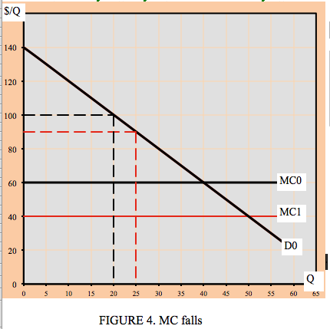For instance, a decrease of marginal cost (see Figure 4) produces the standard supply and demand result: a reduction of price and an increase of quantity offered. In other words, even a monopoly firm has a reason to “pass the savings on to the consumer.” Particularly memorable is that if MC falls by $X, the optimal price decreases by $X/2. I.e. the firm passes on some of the savings. Students find this plausible. So do I.

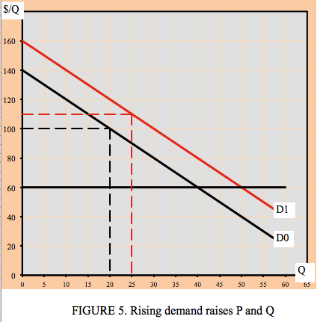An increase of demand -- provided it involves an increase of the intercept A -- produces the general supply and demand result of increasing both price and quantity offered. See Figure 5. This is interesting for two reasons: First because it agrees with, and validates, the use of supply and demand analysis in a non-competitive case. Second it is illuminating that even in the absence of increasing costs a firm will probably (see below for exceptions) increase its price in the light of increased demand for reasons other than increasing costs -- “because it can.” Increasing costs are the only reason that perfectly competitive markets respond to higher demand with higher prices. Of course, a firm with increasing costs will have an additional reason to increase price if its demand rises. (Symmetrically interesting is that the price increase will be equal to one-half of the increase of A.)

BUT … The laws of supply and demand may mispredict when applied to imperfect markets.
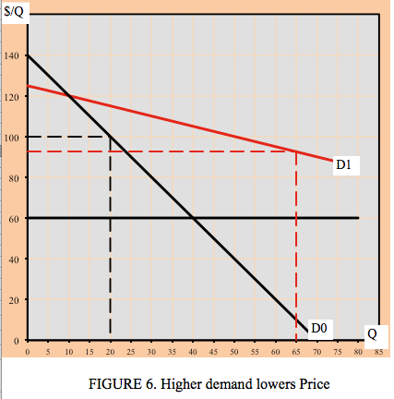It is possible that an increase of demand results in lower prices. This could result if, in addition to rising, the demand curve also becomes more elastic. For this to happen, the parameter A must fall (lowering the demand intercept and, hence, the price) while the parameter B also falls indicating more elastic demand and tending to raise Q* = (A+v)/2B. See Figure 6. Examples and applications of this possibility are discussed below.

We can see that the laws of supply and demand -- which predict an increase of price, given a rise in demand -- may fail when applied to markets that are not perfectly competitive. This failure is especially likely in the face of a shift of the demand curve, since it is the supply curve that most often loses its theoretical underpinnings outside of perfect competition.

Price discrimination and Two Demands
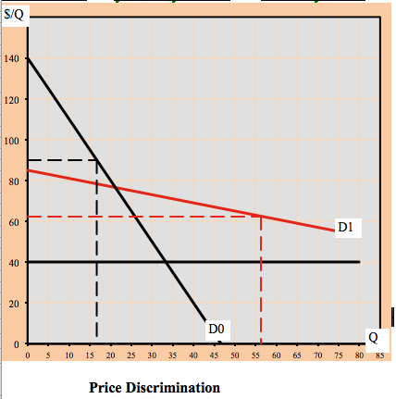Constant costs greatly simplify the exposition of price discrimination, which depends on the existence of (at least) two demand curves. The accompanying figure shows the profit-maximizing prices corresponding to each of the demand curves.
A neat example of this is the after-Christmas sale of ornaments. On December 26th the curve D₀ effectively disappears, leaving only D₁, the demand from price-sensitive shoppers. (Granted this problem can be presented other ways -- as an inventory cost problem, for instance -- but I submit that this method has merit, too.)

D₀ and D₁ also neatly portray the likely demand curves for rich and poor consumers: a few rich who can pay a lot, and many poor who can pay much less. The opportunities for price discrimination are interesting. There is a separate Excel program on price discrimination.

Oligopoly
P₀
$/Q
Q
Q₀
D
d
P₁
Q₁
q₁
Oligopoly
v
ATC
P₂
The constant cost model is a most helpful (though not really crucial) part of an oligopoly model, useful for demonstrating prisoner’s dilemma logic. In the Figure
Curve D is the firm’s demand curve on the assumption that all firms charge the same price.
Curve d is the firm’s demand curve on the assumption that all other firms continue to charge P₀ while the firm changes its price.

The graph, beginning for convenience at zero profit, shows the twin impulses of cooperation and competition to which a firm is subject. It shows two possible ways that the firm could earn positive profit:
1. compete by having a lower price. The firm moves to (q₁,P₁) with price greater than average cost.
2. collude to have all firm raise price together to P₂.

A price war. A price war story can be developed. If a firm lowers price to P₁ its profit rises until firms retaliate driving the firm to an unprofitable position at (Q₁, P₁). Once at that point, there would be a new curve d1 (not shown here) going through D at P₁, showing the effect of changing price when all other firms charge P₁. This curve emphasizes the difficulty of raising a price in a price war. With the firm at (Q₁,P₁) one of two things can happen:
1. all firms together raise price, or
2. firms are forced out of the industry. Their exit will raise demand to the survivors until P1 is at least a zero-profit price.

The whole process of competition leads to examples of Game Theory, Nash equilibriums and the prisoners’ dilemma.

The kinked demand curve. If the firm always assumes the worse -- price increase are ignored while price decreases are matched -- then the familiar “kinked demand” results, as shown in the shaded curve in the Figure.
$/Q
Q
D
d
Kinked D
v
ATC

Thanksgiving: applications.
It is common for turkeys to go on sale before Thanksgiving. This contradicts the supply and demand prediction that an increase of demand results in a higher price. The constant cost model will be used to present several different answers as to why supply and demand fails to give the correct answer.

a. Supply has become synchronized to demand. What we see at the holiday reflects the artificial life-cycle of the turkey, now engineered to reach market size at the right moment. For this argument to work, we need to suppose that turkey production is a decreasing cost industry, so that large quantities are produced more cheaply than small quantities. There is doubtless some truth to this description, but I personally think it evades the question.

b. The Loss Leader. A unique characteristic of turkeys at Thanksgiving is the extent to which that item is the centerpiece to a lavish meal. Selling turkeys cheap is largely a marketing strategy designed to get the buyer to spend a lot on the other components of that meal. Frequently that is made explicit by requiring a minimum purchase to secure the low price.
MC
D0
P0
P1
Q0
Q1
Fig.8 Profit maximization, P>MR
P
Q
MR1
D1

An interesting way to picture the situation is to recognize that the other components of the meal constitute part of the marginal revenue of the turkey. The effect is that marginal revenue can be greater than price, even after accounting for the revenue lost due to price reduction. Equating marginal cost and revenue results in price less than marginal cost on Thanksgiving, whereas price is greater than marginal revenue on other days (at D₀) where the sale of a turkey does not generate the same sort of additional revenue. See Figure 8.

c. The elasticity of demand rises as demand rises. Perhaps at Thanksgiving people shop more carefully -- i.e. their demand is more elastic -- than usual. This would become especially true once the tradition of turkey sales becomes entrenched. In this model, it is necessary that, while the curve shifts upward in the vicinity of (Q₀,P₀), it also rotates sufficiently to reduce the intercept and thereby reduce the price since P = (a+v)/2. The graph is the same as that used for price discrimination above.

d. Thanksgiving represents an opportunity to raise profit by breaking with cooperative behavior. Explicating this version requires using the oligopoly model developed above, in which the firm has two demand curves and where the competitive urge to undersell rivals becomes irresistible on an occasion so sporadic and ephemeral that it does not generate the learning among firms necessary for cooperative behavior.
This behavior is supported by the special characteristics of the holiday: the big meal and the consumer expectation of a sale (i.e. increased demand elasticity) based on past price wars. The result is an example in which, once someone breaks rank and sells cheap, a tit-for-tat strategy results in inevitable uncooperative behavior.

Several other events may fall under the same model.
1. The Happy Hour phenomenon represents another case where price falls in the face of an increase of demand.
2. Immediately before July 4th, items such as soda, beer and hot dogs routinely go on sale. The holiday that has stubbornly resisted this trend is Valentines Day where an increase of demand dutifully creates a higher price for roses.
3. Lots of people put Christmas lights on sale during the Christmas season.
4. Certain items go on sale right before, or as, the demand for them would be expected to rise. Bathing suits and air conditioner repairs are often put on sale right before summer. This is apparently an attempt to get the jump on the competition. In general, market situations in which rivalry is an essential part of the explanation are too far from the Perfect Competition model to be always correctly described by simple supply and demand.

I am suggesting that the case where price falls when demand rises is a substantial exception to the standard supply and demand result. I believe it is substantial enough so that (1) many students are aware of it and even consider it to be the general case and therefore (2) we might want to mention it rather than ignore what appears to be a substantial “fact” of economic life.

Technological change.
A rather different application of the constant cost model is its use in describing the process of technological change. In a constant cost world, a technology is specified by its marginal cost (v), its fixed cost (F), and (if needed), its capacity rate of production (Qcap).

The process of technological change often involves the substitution of fixed costs for marginal costs. New capital generally represents a fixed cost that is worth paying if and because it results in lower variable costs per unit and/or an expanded rate of output. A new technology becomes viable (profitable) when the decreased marginal cost and increased maximum output are sufficient to pay for the increased fixed cost.

This entire idea is considerably easier to expound if one is at liberty to treat marginal cost as constant. See Figure 9, in which MC₀ and ATC₀ represent the lower technology. The picture is drawn so as to show constant returns to scale. At capacity, ATC is the same for both scales of operation.
Fig. 9 High and Low Technologies

MC₀
MC₁
Q
$/Q
ATC₀
ATC₁

From the condition that π* = (A - v)²/4B - F we can see that a new technology is appealing if:
F is low and v is low. No surprises here.
A is large and B is small: that is, if demand is high and elastic. Paying for expensive fixed costs is only feasible in a large market; lowering marginal cost is attractive if it accrues to a lot of units and if the ensuing reduction in price will attract the many customers required to pay for the large fixed costs (i.e. if demand is elastic).

The last point (arguably) illustrates Adam Smith’s dictum that, “The degree of specialization is determined by the extent of the market,” where I believe that “degree of specialization” could be replaced by “degree of capitalization.”
This model at least partially endogenizes technological change by making it a function of the size of the market. This suggests (but does not guarantee) a declining cost paradigm by suggesting that the higher demand is, the more likely it is that a technology with high fixed cost and lower marginal cost and potentially lower price will be profitable.

In Figure 10, D₀ will not support as large a technology as will D₁. The increase of demand has two off-setting effects on price
Q
$/Q
v₀
v₁
D₀
D₁
P₀
P₁
Fig. 10 Increased demand lowers price
a. higher demand tends to raise price by raising A.
b. lower marginal cost tends to lower price, by lowering v when new technology is adopted.

This points to a fact of modern economic life that most students understand but which is not often covered in class. It is the fact that prices for a new item will fall if the item becomes popular enough to evoke mass production. This certainly describes the advent of CDs and DVD players: their prices fell precisely when and because the demand for them was high.

A segue to Increasing Cost
The constant cost model provides a possible introduction to some of the reasons for, and implications of, increasing costs in the real world. Alternately, if the increasing cost model has been used earlier in the course (as is likely in the context of the perfect competition model) there are useful insights to be had in the return to that model.
Suppose that students are now in the habit of considering marginal costs fixed. One must go and examine why it is that, if the firm begins to produce at a high rate of output, marginal cost will likely not remain constant, but will begin to rise, as shown in Figure 11.
$/Q
Q
MC
Fig. 11 (Re)introducing
Increasing Costs

Possible reasons for this include paying overtime, difficulty in obtaining materials, declining employee morale, equipment break-down, and so on. It can be stressed that failure to understand and account for increasing costs, and merely extrapolating the initial marginal cost, is a serious mistake for a business.

It seems appropriate that any foray into the constant cost model should end with a debriefing that brings students back to the frequent usefulness of a belief in increasing costs in the short run.

Two further points can be either introduced or reiterated at this point, if desired:
1. Why the typical marginal cost curve slopes downward at low levels of output.
2. The difference between average variable costs and marginal costs.

CONCLUSION
Most of the above applications did not depend on the constancy of marginal cost for their results. The point of assuming constant costs is to simplify the exposition so as to high-light the role of demand characteristics when the behavior of cost is not crucial to the outcome. Though the presentation here is primarily graphical the same useful simplicity manifests itself if trying to offer concepts via numerical examples or even wholly verbal description.

Undoubtedly one of the points to be made in a micro principles course is the extent to which increasing costs are (at least in the short run) a dominant, and not always intuitively-grasped, facet of reality. Any teacher should think twice about using a model that allows students to lapse into the constant-cost view of the world. That danger stands in contrast to the simplicity of a model that so clearly explicates so many issues -- particularly those related to firms’ pricing decisions.

The vocabulary I have adopted is that there are two kinds of firms: PComp and NotPComp, with monopoly, monopolistic competition and oligopoly as noted subcategories.
If this seems doubtful, ask the accountant for a small business to answer the question, “What is the variable cost per unit of your product.” If the accountant answers with a single number, they agree with my simplification.
Whether the algebra belongs in a particular class is a matter of instructor taste. I assume an instructor is better prepared having given the algebra some thought.
Pause to note in all these applications how much harder they would be graphically without the CCM simplification.
This is closely linked to my preoccupation with Demand Anomalies, pursued in a separate article.
This possibility could describe why a larger firm would allow a smaller firm to undersell it. The reduction of profit to the large firm from engaging in a price war at P₁ might be higher than the foregone profit from letting the small firm take a small piece of market share.
Or at least the distance between P and MR is reduced.
I think this paragraph has received far too little attention if our purpose in micro is to describe some fundamental facts of economic life.
One can define increasing and decreasing returns to scale analogously.

