**MARKET MODEL: THE DEMAND SIDE.**

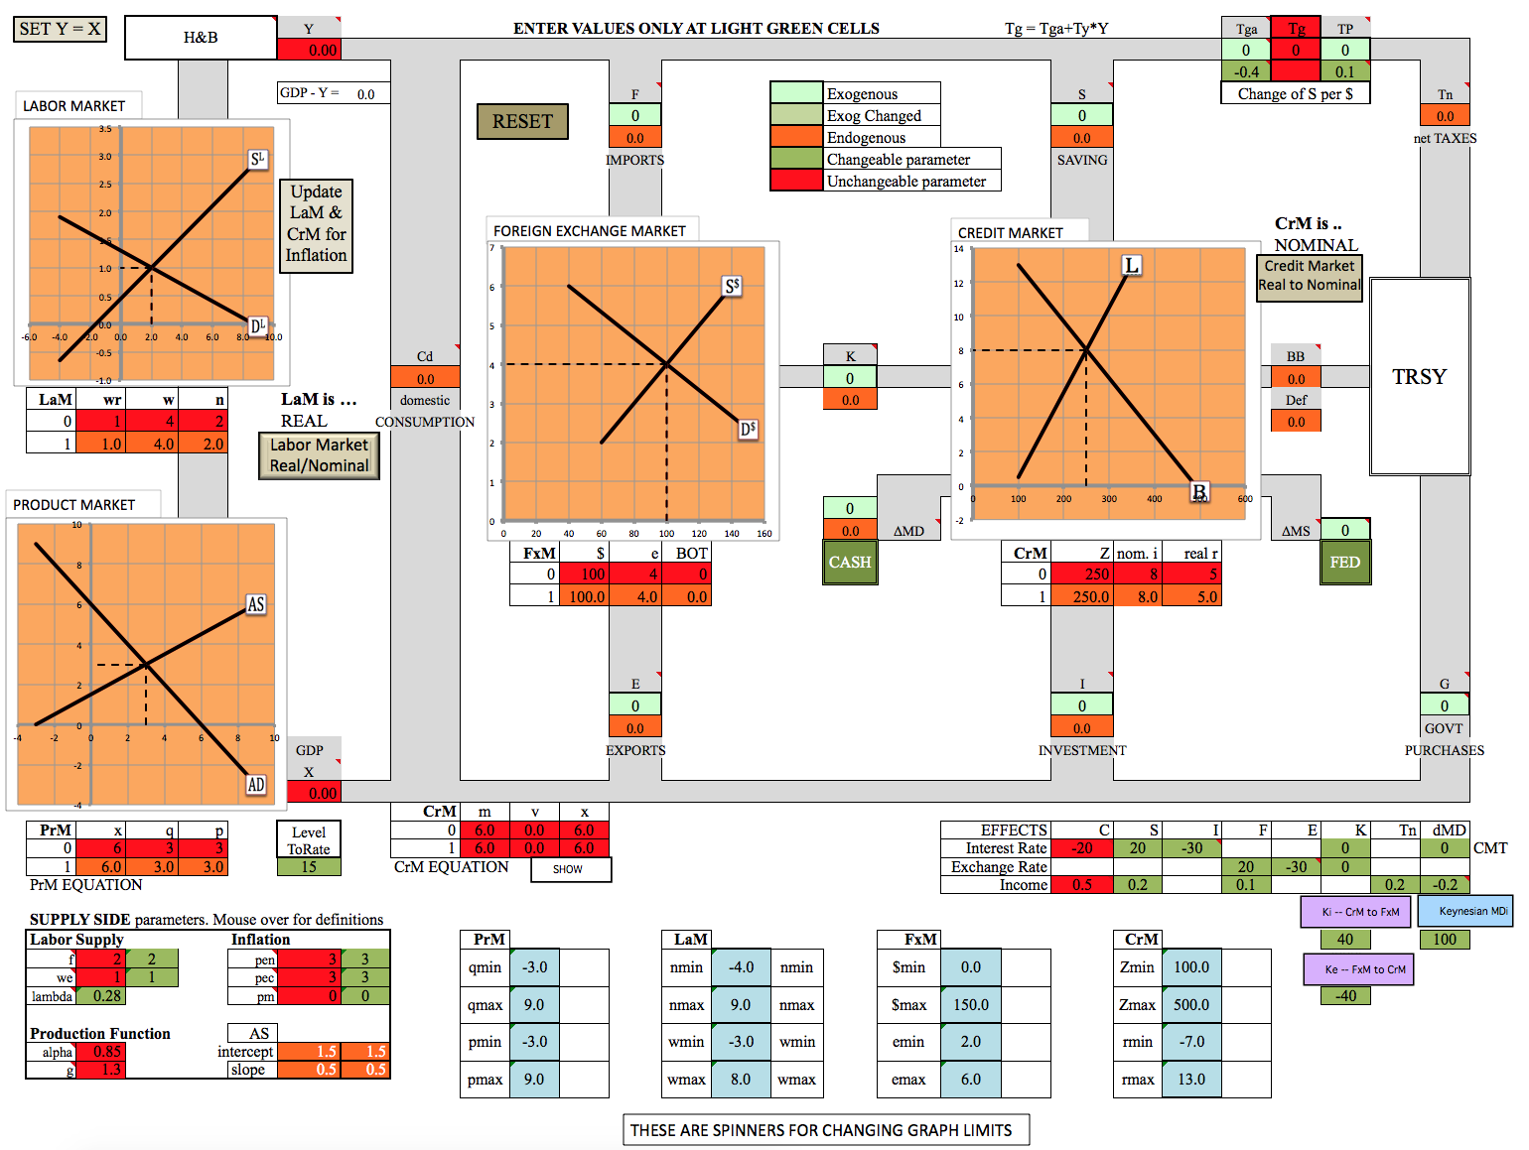

The above diagram shows the Market Mode of the CirF Model.[1]

1. In Market Mode the user enters one or more values (“What happens if this change occurs?”) and the program calculates values for the rest of the variables, according to user-modifiable equations. These results are presented by way of:

a. tables of numerical examples

b. supply and demand graphs of four macro markets: Product (PrM), Credit (CrM), Foreign Exchange (FxM) and Labor (LaM)

2. The right side of the model looks much like Flag Mode, but on the left, Market Mode includes the supply side of the economy – the product and labor markets. In this part of the model calculations turn to rates of change (e.g. inflation, real growth, wage growth etc.)

**THE DEMAND SIDE**

Different colored cells have different purposes. The user enters new values into the light green cells to observe the effects. These changes come in two varieties:

1. exogenous changes to a variable (taxes, for instance), and

2. changes of a parameter value.

Olive color indicates a light green cell that has had its value changed by the user.

As in Flag Mode, the basic relationships hold:

Y = C + F + S + Tn

X = C + E + I + G

BB = Tg – G – TP

F = E + K

I = S + K + BB + MD + MS

|  |  |  |  |  |
| --- | --- | --- | --- | --- |
| **Notation** | **Variable** |  | **Notation** | **Variable** |
| BB | Gov’t Budget Balance |  | H/B | Households & Businesses |
| BOT | Balance of Trade |  | I | Investment |
| Cd or C | Domestic Consumption |  | Kf | Foreign Capital Flows |
| CrM | Credit Market |  | PrM | Product Market |
| Def | Gov’t Budget Deficit |  | S | Saving |
| dMD | Change of Money Demand |  | Tg | Gross Taxes |
| dMS | Change of Money Supply |  | Tn | Net Taxes |
| E | Exports |  | TP | Transfer Payments |
| F | Imports |  | X | Spending = GDP = AD |
| FxM | Foreign Exchange Market |  | Y | Income |
| G | Gov’t Purchases |  |  |  |

**Results are displayed in several ways:**

1. the SnD graphs of the four markets

2. the tables of hypothetical numbers, consistent with the SnD results

3. the numbers in various boxes

**An Example.** Let’s look at the effects of an increase of consumption … except that we can’t. Consumption is something of an exception. It is treated as the residual in this model so it cannot be directly changed. But we can change Saving, which is the same thing. We can use S = -100. To start, we’ll set some parameters.

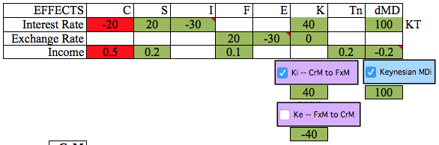-- Check the box “Ki – CrM to FxM” This ensures that the Foreign Exchange Market is linked to the Credit Market by interest rates.

-- Check the box “Keynesian MDi” This creates a Keynesian answer to the question

-- Uncheck the box for Ke (I don’t use this much/at all)

-- In the light green box above the letter S, enter -100. A lot of things change.

1. Graphically, the supply of Credit has decreased (shifted left, what appears to be ‘up.’) due to less saving. The leftward shift is mediated by money coming out of CASH, tempted into the credit market by higher interest rates. In the table of hypothetical numbers (below the Credit Market graph) we see that nominal interest rates (nom. i), real interest rates (real r) have risen, while the quantity of Credit in use (Z) has fallen. (Real r = Nominal i minus inflation)

2. Directly beneath the box where you entered S = -100, you see the number -89.5. Here’s what happened. Saving autonomously fell by 100. But then interest rates rose, increasing the amount of saving. In net, saving only fell by the 89.5.

3. In the FxM we see that higher interest rates raise the demand for dollars, as dollar capital flows become more profitable. This increased demand for dollars raises the exchange rate (e) and the number of dollars traded ($)The higher exchange rate (stronger dollar) raises imports (F) and lowers exports (E) causing a trade deficit equal to the capital inflow.

This is a fairly sophisticated problem. It can be made simpler in a variety of ways. Do note the iron rule of CirF, that X = dMD + dMS. (Since we are dealing with *changes,* the initial value of most variables – specifically Y in this case – is zero.)

**Changing Variables.** We can now, for different problems, change E, F, K, dMD, dMS, S, I, Tga (gross taxes), TP, G, by entering values in the light green cells on the tableau.

**Changing Parameters**. Beneath the tableau, there are darker green cells that can also be changed. These are the coefficients on various equations. To use an example of International Capital Flows (K), the equation that determines K is:

K = Ka + Ki*(ir-ir0) + Ke*(e – e0) where:

Ka = the exogenous part of K. This is what is changed by entering a value in the light green cell under the symbol K.

Ki = the sensitivity of K to interest rate changes. A value of Ki = 40 means that every 1% increase of interest rates will increase capital inflow by $40.

Ke = the sensitivity of K to changes of the exchange rate. A value of -30 (one would expect this to be negative) means that a 1 unit increase in the exchange rate will cause a $30 reduction in capital inflow (or cause a $30 increase of capital outflow).



All the parameters in the dark green cells can be modified to suit a user’s taste.

I would imagine that a novice user would initially accept my defaults and explore elsewhere. I think a seasoned user would experiment, find a set of acceptable parameters and stick with those. There are a few exceptions, corresponding to the three check boxes in the picture above.

1. **Ke – FxM to CrM.** This is the least important. I think that this should be left at zero, but if you check the box, the value of Ke will be set to -40 (which you can change if desired).

2. **Ki – CrM to FxM.** This parameter operates like Ke. The check box toggles between 0 and the value beneath the purple box – shown as 40. This value is important because the interest rate sensitivity of Capital Inflows is important in monetary policy. When monetary changes effect interest rates – as is usual – one should be aware of the Foreign Exchange implications. I.e. one would want a positive value for Ki. However, there time when including the foreign sector unnecessarily complicates problems. In that case being able to push a button and turn off the foreign sector is useful.

3. **Keynesian MD**.This determines the value of MDi – the extent to which CASH (money demand) is affected by interest rates. This is, to me, an absolutely crucial element of the model. As was developed in Flag Mode, the extent to which CASH operates in an economy is, to me, a critical variable, especially as it differentiates between Keynesian and Classical theories.

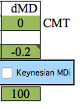Pure Classical Theory uses a 0 here – There are no significant changes of CASH in the Classical model. Unchecking the box inserts a 0 for MDi, as shown. It also puts a little CMT (Classical/monetarist) reminder next to the value.

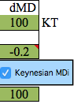Checking the box inputs the number 100 (or whatever number the user puts in the green cell beneath the blue box) and the little KT (Keynesian Theory) indicator.

A user may also directly input any number into the MDi cell. Any number other than 0 is considered Keynesian, but it worth noting that being able to adjust this parameter establishes that one need not adhere to an extreme position. There is room in the middle.

Having this toggle-box allows one to quickly run a problem twice in a row, one with each theoretical perspective.

**SEE** MARKET MODE DEMAND EXERCISES for more examples.

**THE SUPPLY SIDE**

The Supply Side of the economy consists of two markets – Product (PrM) and Labor (LaM). A defining characteristic of the way these two markets are presented is that the price and quantity variables are expressed as *rates of change.* That is, the variables on the PrM axes are the inflation rate and the real GDP growth rate. In the LaM, the variables on the axes are the growth rates of wages[2] (w or wr) and employment (n). A notation convention is that all rates of change are denoted by lower case letters. When considering actual data, I use year-to-year rates of changes.

|  |  |  |  |  |
| --- | --- | --- | --- | --- |
| PrM variables | |  | LaM variables | |
| x | nominal growth |  | n | employment growth rate |
| p | inflation |  | w | wage growth rate |
| q | real growth |  | w | real wage growth rate |

**Real vs. Nominal.** A nominal value is typically the ‘actual’ value of a variable; a ‘real’ value has been adjusted for inflation. With rates of change the process (actually a very good approximation) is very simpe:

Real Rate = Nominal Rate – Inflation Rate, so:

Real GDP growth = Nominal GDP growth minus the Inflation Rate (i.e. q = x – p)

Real Wage growth = Nominal Wage growth minus the Inflation Rate (i.e. wr = w – p)

**The Supply Side**

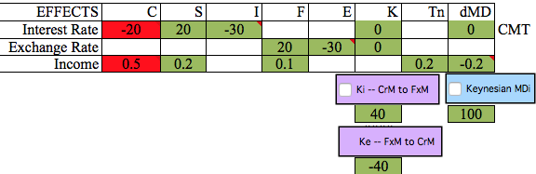Let’s start the examination of the Supply Side by keeping the Demand Side simple. All we need for now is something that raises X. Set MDi = 0 (we’ll use Classical Theory) and Ki = 0 (we’ll ignore the Foreign Sector).

The easy way to increase total spending is to raise MS by 50. Enter 50 at MS and X (aka nominal GDP, aka Aggregate Demand) rises by 50. This number is converted to a nominal growth rate (x) according to the equation x = 6 + X/LtR.[3] This implies that nominal GDP normally grows at about 6% (i.e. when X = 0)

The graph of PrM shows the increased spending as a rise of AD, raising both real growth (q) and inflation (p). Beneath PrM is a table that shows hypothetical numbers. I generally use x = 6, p = 3, q = 3 as a starting, ‘normal’ state. This is ball-park correct, though all the numbers are a bit high for the last years.

|  |  |  |  |
| --- | --- | --- | --- |
| **PrM** | x | q | p |
| 0 | 6 | 3 | 3 |
| 1 | 9.3 | 5.2 | 4.1 |

The Labor Market has n – employment growth – on the horizontal axis. Whether real or nominal wage growth belongs on the vertical axis is a choice for the user. There are advantages to each.

The check-box can be toggled to allow this choice. If this is set to ‘NOMINAL’ we see an increase in the demand for labor with the resulting increases of wage and employment growth. Set to ‘REAL’ we see what I consider an interesting result – an increase of labor supply. This happens because *real* wage growth has *fallen* i.e. nominal wages have risen, but less quickly than inflation. The usual explanation is that workers have been tricked by ‘money illusion’ into working more cheaply, or that labor contracts slow down labor’s ability to adjust to changing inflation.

Labor Market

Real/Nominal

**Supply Side Parameters.** There are a variety of variables below that tableau that permit supply side changes. The user can change the variables in the dark green cells.

|  |  |  |  |  |  |  |  |
| --- | --- | --- | --- | --- | --- | --- | --- |
| **Labor Supply** | |  |  | **Inflation** | | |  |
| f | 2 | 2 |  | pen | 3 | | 3 |
| we | 1 | 1 |  | pec | 3 | | 3 |
| lambda | 0.275 |  |  | pm | 0 | | 0 |
|  |  |  |  |  |  | |  |
| **Production Function** | | |  | AS |  | |  |
| alpha | 0.85 | |  | intercept | | 1.5 | 1.5 |
| g | 1.3 | |  | slope | | 0.5 | 0.5 |

|  |  |
| --- | --- |
| **Variable** |  |
| f | growth rate of the labor force |
| we | an indication of the strength of labor’s bargaining power (‘expected wage growth’) |
| lambda | the slope of the labor supply curve |
| alpha | a number denoting the productivity of labor |
| g | exogenous technological growth |
| pen, pec | inflation expected by labor and capital. There is a button, “Update LaM and CrM Inflation.” The effect of that button is to replace pen and pec with the actual inflation rate. This shows Labor catching up with inflation and derives the Long Run AS curve. |
| pm | the relative rate of material input inflation. This is here largely to model the 1970s oil embargo. A value of zero implies that materials inflation equals overall inflation. A cost-of-materials recession is shown by raising this number. |

The numbers under AS show an ‘intercept’ of 1.5 and a ‘slope’ of .5. This means that the chosen parameters have resulted in an Aggregate Supply curve of p = 1.5 + .5q. This implies that when q = 0, e.g. the economy is entering or exiting a recession, we expect inflation to be 1.5%. The .5 says that, if Aggregate Demand rises, inflation will rise by ½% for every 1% that real growth rises. These numbers are actually ball-park accurate.

We now can solve the PrM:

The AD equation is merely: p = x – q. The AS equation is p = 1.5 + .5q. For x = 6, the solution is: p = 3 and q = 3.

We can now examine some purely supply-side questions and, for now, entirely ignore the demand side. To do this RESET. The following exercises will keep AD it’s 6% growth rate and, keeping Demand constant, look at supply-side effects.

**Effects**

1. Illustrating a reduced labor force (e.g. the great retirement) means reducing the labor force growth parameter, f, from a 2%, 0%.

We see left-shifted supply curves in both PrM and LaM. Inflation rises; growth slows, wages – real and nominal – rise, employment slows.

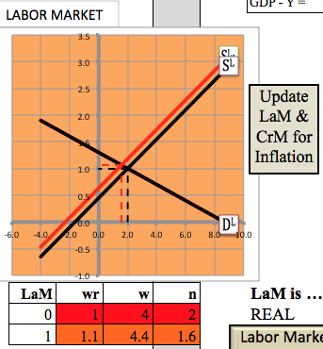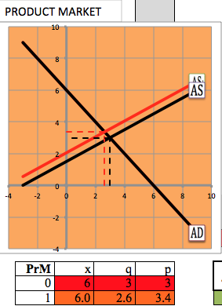

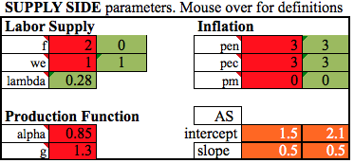

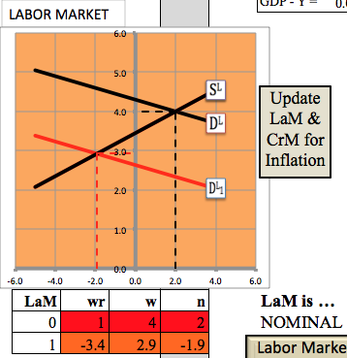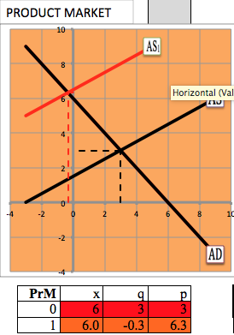2. Illustrating a cost-push, increase of materials cost situation, (e.g. rising price of oil) requires raising the parameter pm – materials inflation. The results are higher inflation, less growth, falling employment, depressed nominal wages and falling real wages.

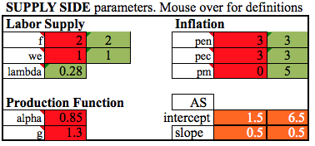

**The Structure and Math of the DEMAND SIDE Model**

Market Mode adds to Flag Mode explicit equations (that can remain unseen to the user) for many variables: C, S, I, etc. to enable the program to solve for those variables.

The Demand side in this model is composed totally of linear equations. For example the equation for Foreign Capital Flows is: K = Ka + Ki*IR + Ke*ER + Ky*ΔY, in which

K = foreign capital flows

Ka = a strictly autonomous (exogenous) portion of K. Typically this is the parameter that a user will change to indicate an ‘event.’ Here an event – an increase of Ka – could be “foreigners want to buy more US bonds.”

IR = the interest rate

ER = the exchange rate

ΔY = the change of income

Ki = the parameter denoting the effect of a change of the interest rate on K.

Ki = 50 means, “K changes by 50 for every 1% change of interest rates.”

Ke = the parameter denoting the effect of a change of the exchange rate on K

Ky = the parameter denoting the effect of a change of income on K[4]

Some “variables” are no more than an autonomous element. They are unaffected by anything else in the economy. These are:

|  |  |
| --- | --- |
| **Variable** | **NAME** |
| G | Government Purchases |
| Ta | Autonomous Gross taxes |
| TP | Gov’t Transfer Payments |
| MS | Money Supply |
| Y | This is a weird special case, described above. |

|  |  |  |
| --- | --- | --- |
| **Var.** | **Name** | **Equation** |
| S | Saving[5] | S = Sa +*Stg*\*Tg + Stp*TP + Si*ΔIR + Sy*ΔY |
| I | Investment | I = Ia + *Ii*\*ΔIR |
| Tg | Gross Taxes | Tg = Ta + Ty*ΔY |
| F | Imports | F = Fa + Fe*ΔER + Fy*ΔY |
| E | Exports | E = Ea + *Ee*\*ΔER |
| K | Foreign Capital (in)Flows | K = Ka + Ki*ΔIR + *Ke*\* ΔER |
| MD | Money Demand | MD = MDa + MDi*ΔIR + MDy*ΔY |
| X | Total Spending, GDP | X = Cd + I + G + E |

Most variables are determined by an equation, as below:

All subscripted parameters can be changed exogenously (i.e. by the user).[6] That is not, however, the principle use of the program. One would hope to find an acceptable set of parameters (e.g. the defaults) and not mess with them thereafter.

There are exceptions to this rule.

1. The effect of interest rates on Money Demand (MDi) is, to me, the crucial variable is this whole program. Changing that parameter is useful. This parameter is therefore presented differently in the program. There are check-boxes to specifically deal with the significant cases where modifying parameters is important.

2. Ke and Ki, the effects of exchange and interest rates on Capital Flows. If these are set to zero, the Foreign Exchange Market is effectively disconnected from the model. It is helpful to set these equal to zero when one is working on a problem for which the foreign sector is not important. It makes it easier to see what is happening. If one is interested in the reactions of the Foreign Sector, then these values should be non-zero. The program includes the ability to turn these parameters on and off. Ki induces changes from CrM to FxM; Ke induces changes from FxM to CrM. I take Ki to be important since it shows how the Fed’s influence on interest rates, affects the Exports, Imports and the Trade Balance. Ke is less important; it is involved in a limited number of issues.

Consumption (C) is a special case. It is strictly *endogenous.*  It is the residual variable computed to solve the system. Consequently, the user cannot change C, though the user can change Saving (S), which accomplishes the same thing.

**Slopes (reaction coefficients)**

|  |  |  |
| --- | --- | --- |
| **Slope Subscript** | **Denotes** | **Examples** |
| a | autonomous | Sa, Ka, MDa |
| i | Interest Rate | Si, Ki, MDi |
| e | Exchange Rate | Fe, Ee, Ke |
| y | Income | Sy, Ty, MDy |
| Stg | Effect of gross taxes on Savings |  |
| Stp | Effect of transfers on Savings |  |
| Tgy | Effect of Income on Gross Taxes |  |

A parameter of the form Ab denotes “the effect of a change of b on variable A.”

Beyond the definition of variables there five crucial equations.

1. Y = Cd + F + S + T

2. The government budget identity: BB = Tg – G - TP (BB = Budget Balance)

3. Foreign Exchange Equilibrium: K = F - E

4. Credit Market Equilibrium: S + K + ΔMD + ΔMS + BB = I

5. GDP: X = Cd + I + G + E

SOLVING THE MODEL. PART 1

Substitute into #1

-- the definition C = Y - S – Tg +TP - F

-- BB = Tg -TP - G and

-- E - F = -K

-- S = I – (K + ΔMD + ΔMS + BB)

After some tedious manipulation, this yields X = Y + ΔMD + ΔMS. (Since Y is set at zero, we can use X = ΔMD + ΔMS) This is deep. It says that the economy expands (X > Y) *if and only if* dMD + dMS is greater than zero and contracts (X < Y) *if and only if* ΔMD + ΔMS is less than zero. None of the other variables can change GDP. A change of a variable other than ΔMD or ΔMS will result in an offsetting change in some other variable(s).

Classical theory has long asserted the power of printing money (ΔMS) to influence nominal spending (and, from there, inflation). It was left to Keynes to accentuate the power of money holding (ΔMD) to influence the economy (from which he stressed the effects on employment rather than inflation).

According to this equation a non-monetary (i.e. barter) economy could never have a demand-side recession.

SOLVING THE MODEL. PART 2

Substituting into the equations for Credit and Foreign Exchange Market equilibrium produces two equations in the interest rate (IR) and the exchange rate (ER). This provides a system of two equations in the two unknowns, IR and ER, which can be solved. Once IR and ER are found, everything else can be computed, including X. We have solved the Demand Side of the economy, culminating in nominal GDP.

CrM Equilibrium is:

(Sa + Stg*Tg+Stp*TP)+ΔMDa+ΔMS+Ka + Tga*TP - G-Ia +(Sy+ΔMDy+Tgy)*Y = [Ii-(Si+ΔMDi+Ki)]*IR –Ke*ER

FxM Equation is:

Fa – Ea – Ka + Fy*Y = Ki*IR+ (Ee + Ke – Fe)*ER

**SOME OPTIONS OF INTEREST and some economics.**

1. **Set Y = X**. The purpose of this button is to illustrate the Multiplier.

**An Example. Let ΔMS = 50, MDi = 0, MDy = 0** (in the EFFECTS table)

X rises. If MDi = 0, we will get X = ΔMS (50 in this example). Notice that throughout this example. X = Y + ΔMD + ΔMS. We see Demand rise in the Product and Labor markets. (Set the Labor Market to “nominal.”). I.e. printing money creates an expansion.

Look at and remember the number for X for a moment.

Press the Y = X button. Y has been updated to equal X (50). A host of changes happen on the Demand Side Tableau. Cd, S, Tn, F have all increased as the results of higher Income. X = 150.

Press the Y = X button again. Repeat and observe, that with each push, X rises by 50. The point is that one can imagine raising nominal GDP without limit by printing enough money.

RESET. Set MDy = -.2. This says that higher income requires the public to hold more money.

Enter MS = 50. X rises to 50. Hit the “Set Y = X” button. This time X only rose by 40 because 10 went to CASH. If you repeatedly push the “Y = X” button Income rises by ever smaller increments. Indeed Income and Spending max out at 250, at which point CASH has taken the entire 50. (Note the 1/leakages multiplier formula at work). So attempts to endlessly print money will meet some resistance.

RESET. Set MDi = 100. MS = 50. This says that higher (lower) interest rates will get money out of (into) CASH. This makes the model more Keynesian. Notice that some of the printed money went into CASH. The effect on X is therefore smaller. Keynes is famous for suggesting that, during recessions, printing money may have limited effectiveness. Start repeatedly pressing “Y = X.” Income and spending rise, but more slowly, peaking out at a far lower value.

2. The “Update Inflation” button. The preceding exercise was done entirely in nominal terms. The inflation that occurred was not considered, as if no one noticed. Now let’s suppose they notice. At each push of the button Labor’s perceived inflation is updated to be equal to the actual rate. The supply of Labor shifts to the left as workers demand higher wages. The AS curve shifts left as well, reflecting the higher wage costs. Keep pushing and eventually real growth of output and employment return to their original values. Printing money cannot produce permanent prosperity. Set the Labor Market to “Real” for an interesting result: Nothing really happened! This is known as “deriving the Long Run AS curve.”

It is a convenient fiction, permeating the whole model, that the two buttons don’t interact. One impacts the demand side, the other the supply side. That makes it easier to illustrate the two fundamental propositions: The ripple effect of any change of spending as that spending becomes income, which changes spending, which changes income, etc.

3. **Ki – CrM to FxM.** The parameter Ki determines the effect of interest rates on foreign capital flows (Kf). A value of 0 means there is no effect. Checking the box will substitute the value 40 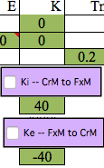for Ki – meaning that a rise in US interest rates will attract a capital inflow. If you don’t like the number 40 you have two choices.

a. Type into the box right below “K” any (non-negative) number you like.

b. change the number 40 beneath the button. That will now become the substituted value when the button is pushed.

4. **Ke – FxM to CrM.** The parameter Ke determines the extent to which exchange rates inversely impact capital flows. The use of the boxes and the button are the same as for Ki.

The reason for the ability to quickly change these two variables is that setting them both equal to zero, effectively disconnects the Foreign Exchange Market from the rest of the economy. This is useful when doing problems that don’t need the FxM, and are kept much simpler by ignoring it. Of the two parameters, I find Ki the more significant, because it links US policy to the rest of the world. Ke can, I think, be left to zero for most applications.

**5. Credit Market – Real to Nominal.** Pressing this button toggles between the variable on the y-axis being the nominal interest rate and the real interest rate.

**6. Labor Market Real to Nominal.** The button is structured as the previous, but it comes with more surprises. To see that RESET and press the button until (right above the button) it reads “NOMINAL.” Now increase the money supply. Exactly what happens depends on all the parameters in effect, but this much will happen: AD will rise and the Demand for Labor (DL) will also rise. This seems reasonable – more spending and production should require businesses to hire more labor.

Now press the button to get a Real Labor Market. There is no change of the demand for labor, but there is an increase of Labor Supply (SL). Looking at the numbers beneath the Labor Market you can see that real wage growth has slowed, but employment has increased – an increase of supply. This is because nominal wages have risen but by less than inflation rose. This is explained either by labor’s “money illusion,” or by the time lag in adjusting labor contracts to inflation.

Using the **Update … for Inflation** button repeatedly will show the SL curve shifting back to its original position, as labor demands higher wages to account for inflation.

7. **AS Curve Shifters.** How much these should be used is an open question.

f = growth rate of the labor force

we = labor’s expected rate of wage growth

lambda = the slope of Labor Supply

This variable can be directly changed or can be selected via the drop-down menu of the choices KT, Inter, CMT, indicating Keynesian, Intermediate and Classical/monetarist labor supply slopes. The numbers assigned to each theory can be user-assigned by a table below the menu.

pen, pec = the expected rates of inflation in the labor supply and the credit market.

pm is the relative inflation rate of materials. Zero indicates that materials inflation equals the general inflation rate. Making this number larger illustrates the oil shocks of the 1970s.

The variables alpha and g cannot be changed. The represent, respectively, the coefficient of labor in the production function and the rate of output growth due to exogenous factors (e.g. technology)

**The AS curve**. My favorite equation for the AS is p = 1.5 + .5q (used as the Intermediate Labor Supply case). This means that as an economy enters a recession – when q = 0 – inflation will about 1.5%. Deflation will occur at q = -3. Inflation, in the short run, rises by .5% for every percent change of real growth. These seem reasonable ball-park values. Furthermore, the equation includes q = 3, p = 3, my favorite starting values for the US economy. The truth has been closer to 2.5 and 2.5, but simplicity is a virtue.

**The Keynesian multiplier.** The ripple effect of a change of spending is, in Keynesian lingo, “the multiplier.” It became known as “pump priming.” A small change of spending produces a larger final result. Here’s the usual Keynesian demonstration, using government purchases. Let’s try to spend our way out of a Depression. We need to adjust two elements of the model to accomplish this.

1. Flatten the AS and Labor Supply curves. An economy with high unemployment is not susceptible to inflation of either goods or wages. In the SUPPLY SIDE parameters, find the selection box (under “Labor Supply Slope”) with the choices KT, Inter and Class. Select KT. The labor and aggregate supply curves become flat.[7]

2. Make the Demand for Money very active. Set MDi = 1000. (That makes the Supply of Credit curve very flat. Now set G =50. Start pushing the “Y = X” button until Y stops changing. Income has risen to over 200. That means that the government’s expenditure of 50 has advanced Income by 200+. The ‘multiplier” is greater than 4 (220/50). Output and employment are growing furiously. Expansionary fiscal policy is Keynes’s solution.

Selecting a Labor Supply Slope to Inter(mediate) results in my favorite p = 1.5 + .5q. Pressing the Radio button “Class” gets a rather steep, rather classical Labor Supply curve.

1. This, more complex model, is likely easier to understand if one has worked with CirF’s Flag Mode.
2. real or nominal at the user’s discretion.
3. The parameter LtR – ‘Level to Rate’— can be user-adjusted.
4. In the actual program I left out Ky. It is here for illustration.
5. The Saving equation is an odd, complicated one because it must be adjusted for changes of Taxes and Transfers, the elements *Stg*\*Tg + Stp*TP
6. Parameters that are non-positive are italicized.
7. The value for the Labor market Slope is user-adjustable.