***CirF*, the Demand Side**

***CirF*** is a series of macroeconomic models, designed to illustrate a host of macro questions and issues. ***CirF*** is based on, and extended from, the circular flow models found in every econ text. ***CirF*** exists in two main forms: Flag Mode and Market Mode. While there are differences, the demand sides of the two are basically the same. Thus this introduction should serve for both of them. All values are nominal. I will first examine Flag Mode.

**NOTATION (for reference)**

|  |  |
| --- | --- |
| **Notation** | **Variable** |
| BB | Gov’t Budget Balance |
| BOT | Balance of Trade |
| Cd or C | Domestic Consumption |
| CrM | Credit Market |
| Def | Gov’t Budget Deficit |
| dMD | Change of Money Demand |
| dMS | Change of Money Supply |
| E | Exports |
| F | Imports |
| FxM | Foreign Exchange Market |
| G | Gov’t Purchases |
| H/B | Households & Businesses |
| I | Investment |
| Kf | Foreign Capital Flows |
| PrM | Product Market |
| S | Saving |
| Tg | Gross Taxes |
| Tn | Net Taxes |
| TP | Transfer Payments |
| Trsy | Federal Gov’t Treasury |
| X | Spending = GDP = AD |
| Y | Income |

|  |  |
| --- | --- |
| **Variable** | **Notation** |
| Spending = GDP | X |
| Income | Y |
| Domestic Consumption | Cd or C |
| Saving | S |
| Investment | I |
| Imports | F |
| Exports | E |
| Foreign Capital Flows | Kf |
| Balance of Trade | BOT |
| Gov’t Purchases | G |
| Gross Taxes | Tg |
| Transfer Payments | TP |
| Net Taxes | Tn |
| Gov’t Budget Balance | BB |
| Gov’t Budget Deficit | Def |
| Change of Money Supply | dMS |
| Change of Money Demand | dMD |
| Household/Business Sector | H/B |
| Product Market | PrM |
| Credit Market | CrM |
| Treasury | Trsy |
| Foreign Exchange Market | FxM |

Alphabetically

**CirF … Flag Mode.** To follow along, open Program_FlagMode. xls. (Enable macros) Find the box labeled SHOW and select the four boxes there. This is intended to be a picture of an economy. Press RESET. You see:

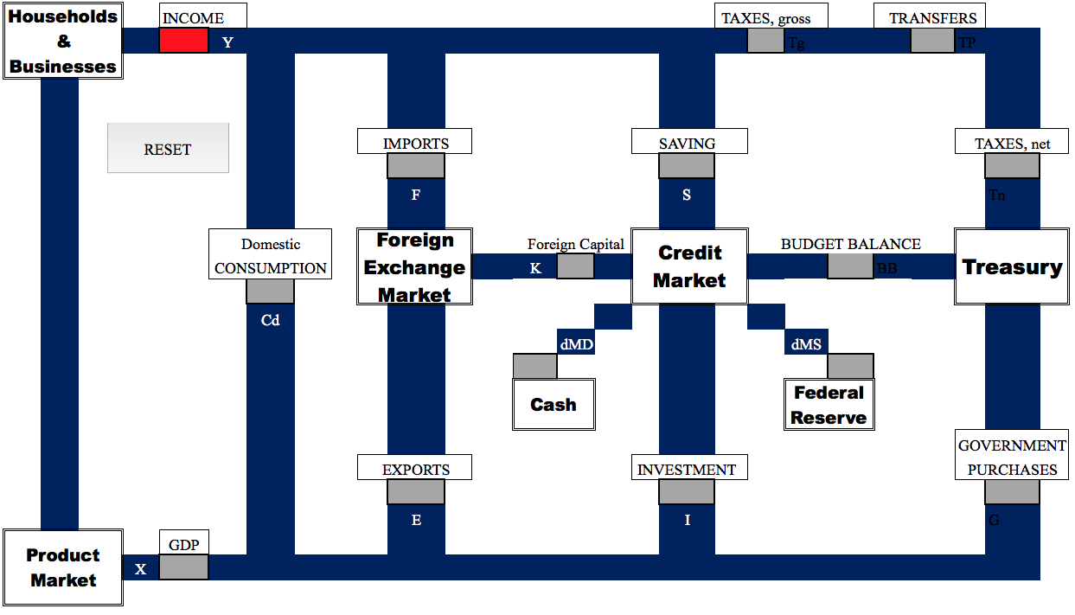

**SECTORS**

Here’s what it means.

Start at the upper left – the **Household & Business** sector (H/B). Y represents (private, domestic) income being spent. The stream of income divides into four substreams, labeled C, F, S and T

That is, income can be used for four things:

1. to buy American products (C for ‘Domestic Consumption’)[1]

2. to buy foreign products (F for ‘Imports;” ‘Fimports’ as a mnemonic)

3. to Save (S) and

4. to pay Taxes.

As an equation: Y = C + F + S + T. [2]

The **Product Market** represents all US stores and factories – ‘where’ stuff is made and sold.

There are four types of spending (X) entering PrM.

1. Domestic Consumption (C) – as described above

2. Exports (E) – spending by the rest of the world on our goods and services

3. Investment (I) – (for now) spending by businesses on capital goods. This is quite a different use of the word investment, which is usually defined as something such as, “Using money in the hopes of earning more money.” There is more to come on defining this term.

4. Government Purchases (G)

We can say there are four sectors – Household, the Rest of the World, Businesses and Government – each with its own type of spending. The sum of these four types of spending (designated X) is total spending, known as Gross Domestic Product (GDP).

As an equation: X = C + E + I + G

The **Foreign Exchange Market** (FxM) is ‘where’ we economically interact with the rest of the world. We buy Imports (F), sell Exports (E) and exchange Capital Flows (K, aka ‘money flowing between financial institutions’).

As an equation: F = E + Kf

The **Treasury** is the part of the Federal government[3] that:

-- Collects gross Taxes,

--Pays out Transfer Payments (Social Security, Medicare, welfare, etc.). The difference between gross Taxes and Transfers is called net Taxes. Tn = Tg – TP.

-- Buys stuff (G – government purchases .. significantly military).

-- Borrows. The difference between what the government collects and spends is the Budget Balance. Typically this is a Budget Deficit – a negative number. The diagram shows this as an avenue between the Credit Market (banks, etc.) and the Treasury.

As an equation: BB = Tg – TP – G.

Finally, the **Credit Market** – banks, the stock and bond markets, etc.

At this point we unfortunately need a vocabulary digression. The definitions of these terms only need to be ‘good enough.’ Don’t search for subtle exceptions. Furthermore, a lesson of the digression on vocabulary is that it is not all that important. It’s a pedant being pedantic.

THE MEANINGS OF C, S and I

The standard *economics* definitions.

C = the purchase of *current produced* goods and services by the household sector[4]

S = that part of household income not used to buy *currently produced* goods and services or pay taxes.

I = purchases by the business sector of *physical capital* (i.e. machines and factories). Note also this does not comport with the layperson definition of investment, which is something such as, “putting money somewhere with hopes of making a return on it.”

Note that the defining characteristic of C and I is, “*who* did the spending.”

Some oddities already:

What one might call an ‘investment’ in the stock market would here be classified as Saving, not Investment.

Debt repayment is Saving. This is actually ‘true.’ Look at ‘currently produced’ in the definition of S but, more importantly, the truth of credit is that when you make a car payment, you are ‘saving up’ to buy the car. The existence of credit means that we are allowed to save *after* we buy something, rather than *before.* If you don’t have the money to buy something outright, then you must save up to buy it.

If we let the diagram define the terms, we get these definitions:

C = Spending *the purchase of domestically produced goods using current income.*

I = Spending *financed by borrowing.*  It comes out of the Credit Market.

S = The part of current income not spent on current output. The previous comments on Saving stand.

In these definitions, C and I are differentiated by “*From where* did the money come?” rather than by “*Who* did the spending?” Two differences with standard economics terminology[5] emerge.

1. Businesses purchases of physical capital out of retained profit (their current income) count as C

2. Household purchases financed by credit (e.g. housing and most automobiles) count as I

Fortunately these issues will not arise much. Actually only one part of this vocabulary discussion matters much. That is when I say the word Investment, I still usually mean something closer to “a business buys a machine” and *not* something such as “putting money somewhere with hopes of making a return on it.”

And while we’re at it: Interest counts (as a good approximation) as C, not S. Interest is a payment for the ‘purchase’ of a current service – the use of someone’s money.

**Digression over. Back to the picture and the Credit Market.**

**S and I:** The diagram confirms that the essential role of the Credit Market is borrow money from those not currently spending it and lending that money to those who want to borrow it. Banks are ‘merely’ go-betweens.

**K:** Since the 1960s, or so, Foreign Capital Flow would be illustrated by an arrow from FxM to CrM. That is, the US is the world’s major debtor/borrower. Put another way, the world is eager to lend money to the US.

**BB:** the Treasury (the federal government) is a major borrower in the form of its negative Budget Balance – the budget deficit. One would (will) draw an arrow to the right, from CrM to Trsy.

**Federal Reserve and dMS:** The ‘Fed’ is the quasi-government agency tasked with regulating the nation’s money supply. That is, the Fed is able to feed money in to and out of CrM.

Notation: the d in dMS stands for ‘the change of’ in the label, ‘the change of the money supply.’ This is sometimes rendered as ΔMS. The point is that it is really only *changes* in the quantity of money that matter. An economy will adjust to any quantity of money, but changes in the money supply may cause other economic changes. I am sometimes careless and just use MS.

**CASH and dMD:** This is the most mysterious piece of the puzzle. I will not attempt to unravel it now – nor will I succeed in unraveling it at some point in the future. CASH (demanding money) refers to the ability of financial assets to be hoarded. *Changes* in what is held and hoarded (dMD) would seem to have economic significance.

As an equation CrM is summarized as: I = S + BB + K + dMD + dMS

**Looking at the whole picture again.**

Repeating the equations from above:

Y = Cd + F + S + T. Uses of Income

F = E + Kf Foreign Exchange equilibrium

CrM: S + BB + dMD + dMS + Kf = I Credit Market equilibrium

BB = Tg –TP – G. Government Budget constraint

X = Cd + E + I + G = GDP. Types of Spending

**The Diagram** is read as meaning that all the money flowing into one of the ‘nodes’ (H/B, FxM, CrM, Trsy, PrM) flows out of that node. Two exceptions are the Fed and Cash. These are ‘places’ where money can, at least temporarily just appear from or disappear to. The ‘money in = money out’ assumptions allows one to write the equations that appear above.

Flag Mode of ***CirF*** is purely a demand side model. Thus, with this tool, there is no discussion of inflation, real growth, wages or employment. Those must wait for the Supply Side of the economy to be introduced with ***CirF***’sMarket Mode. Exercises will ask the user to invent numbers, consistent with the constraints of the diagram, to describe a variety of situations. For example the user might be asked, “What is the effect of households increasing Cd by 50?” Problems typically end by saying what happened to X (aka nominal GDP, aka Spending): whether it rose, fell or was unchanged as a result of some given event.

**A review.** As a quick review of ***CirF***, return to the computer. It is important to using ***CirF*** that one can use only parts of it as needed. Simple is good. On the computer program de-select all the SHOW options to get the simplest version of ***CirF***.

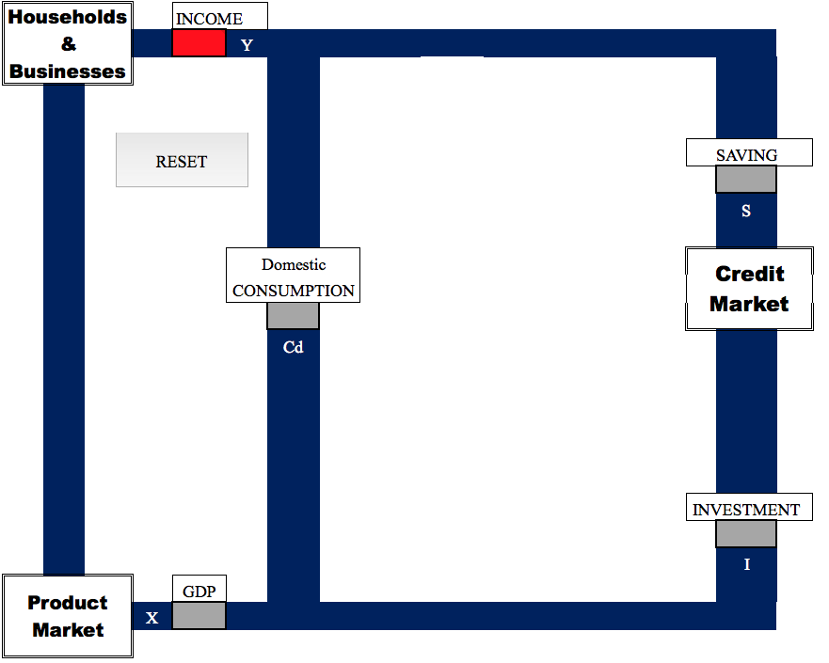**I. The Simplest Model**

The economy is now described by:

Y = Cd + S

X = Cd + I

S = I

**II. Money D and S – the ‘monetary components.’ SHOW** CASH and FED

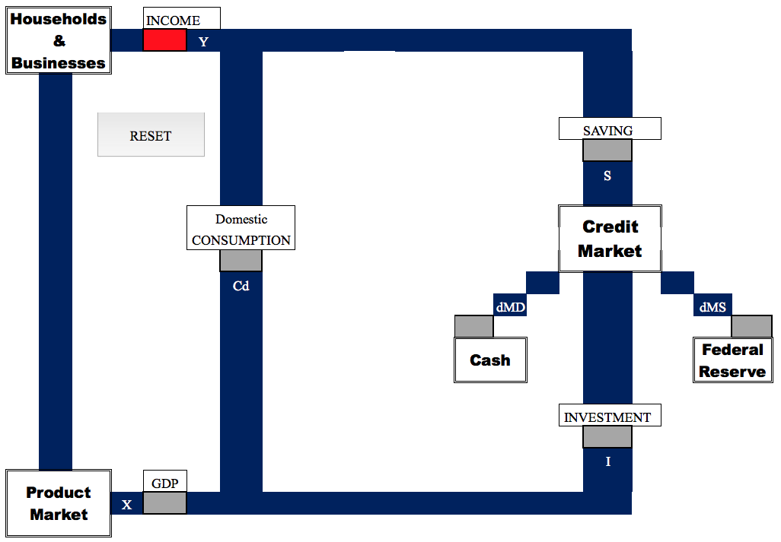

We now have:

Y = Cd + S

X = Cd + I

S = I + dMS = dMD

**III. Treasury and Fiscal Policy. SHOW** TREASURY

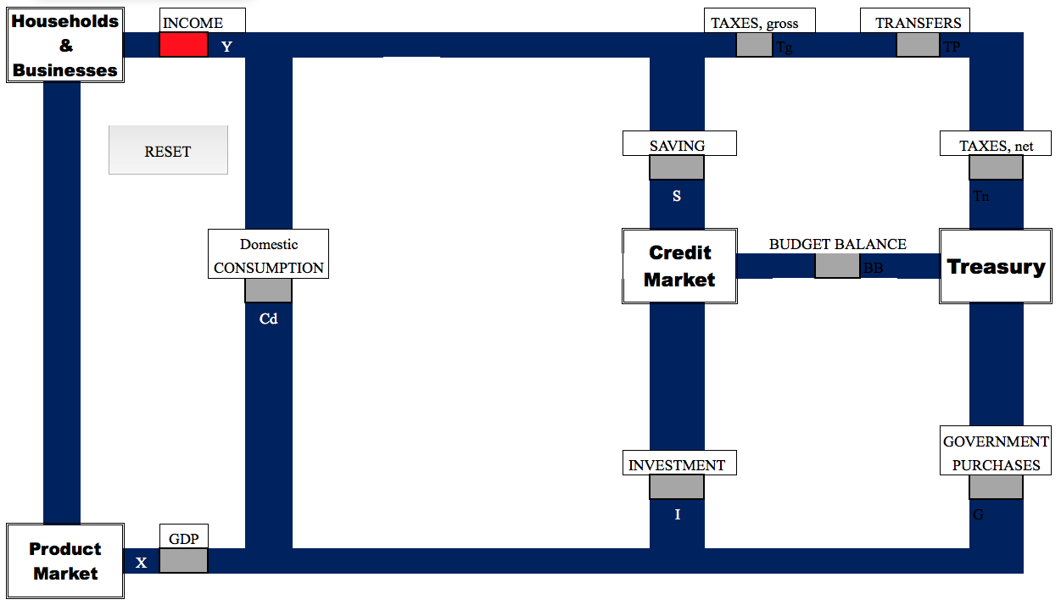

Y = Cd + S + Tn

X = Cd + I + G

S = Def + I

BB = Tg – TP – G

Tn = Tg – TP

(I removed the monetary components. You may keep them if desired. There are certainly problems that require that they be there.)

**IV. The Foreign Sector and the Foreign Exchange Market. SHOW** FOREIGN EX.

We can now look at issues of foreign trade: exports, imports and international capital flows.

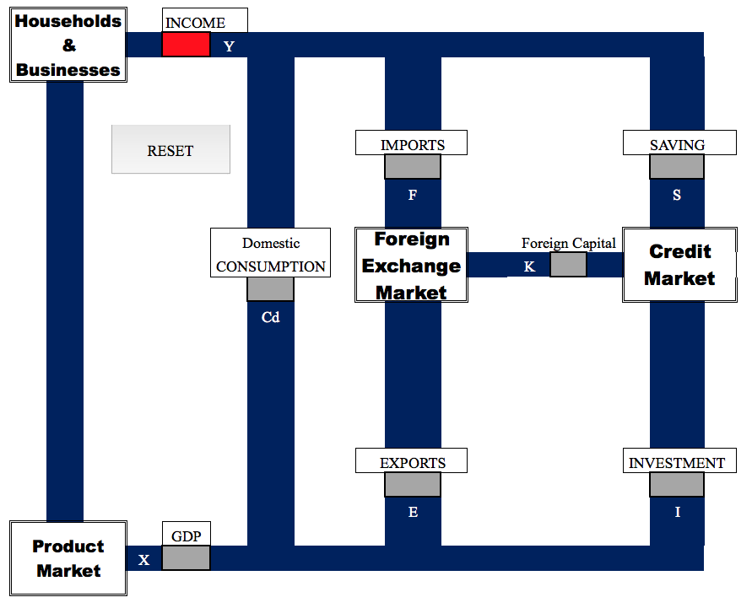

Y = Cd + F + S

X = Cd + E + I

S + Kf = I

F = E + Kf

**V. The Complete Model. SHOW all**

With all the pieces in place we return to the complete model. One would use the complete model to illustrate how the various elements interact.

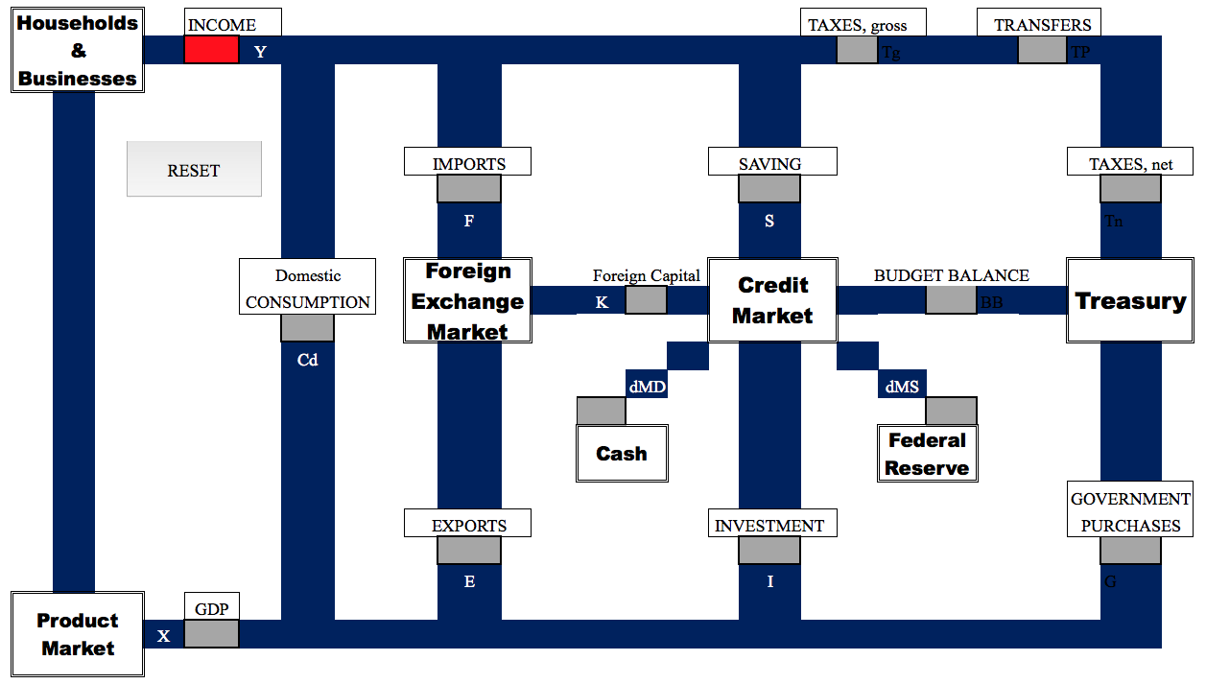

Y = Cd + F + S + Tn

X = Cd + E + I + G

S + Kf + BB + dMD + dMS = I

F = E + Kf

BB = Tg – G –TP

Tn = Tg – TP

With this introduction we can proceed to actually talking about economics, by way of exercises and examples.

1. Note that imports are not considered part of ‘C.’ Imports are considered separately as ‘F.’
2. If you think ‘Investment’ belongs here, hold on. We’ll return to that.
3. State and Local governments are largely ignored.
4. I don’t want to go in to it, but resold goods don’t count. That is merely an exchange of assets within the H/B sector. I do believe there is a dark secret hidden in this, but so be it.
5. called National Income Accounting